Spletne strani, informacije:

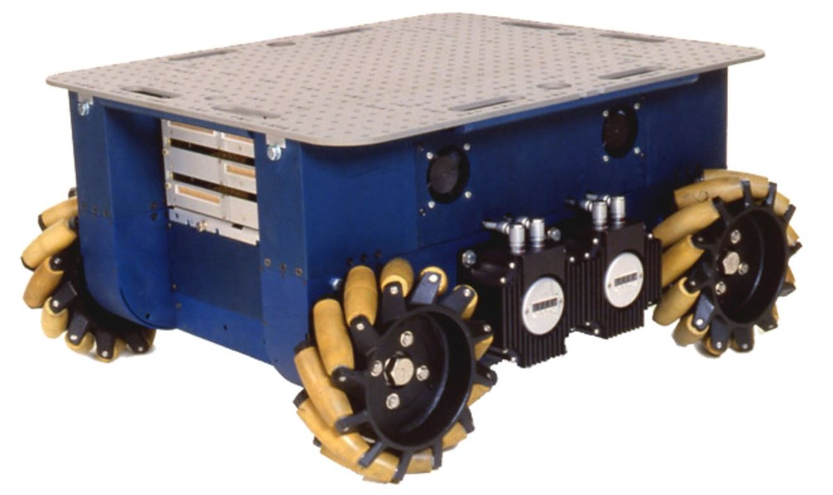



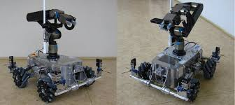

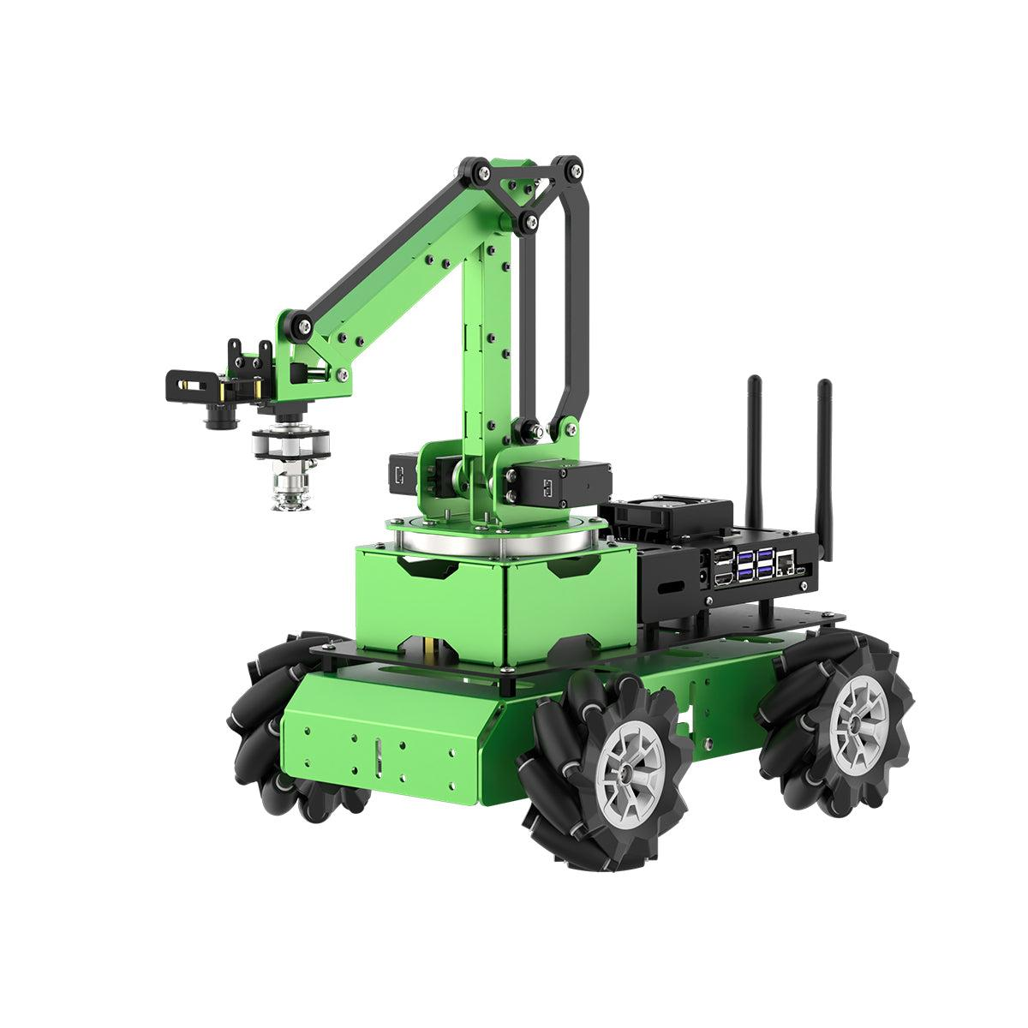

<https://www.youtube.com/watch?v=noqBUEgyQ8A&t=275s>

<https://www.youtube.com/watch?v=83tVkgT89dM&t=549s>

<https://www.youtube.com/watch?v=8qtVhCtRoDY&t=21s>

<https://www.youtube.com/watch?v=Q3pCpVepCxk&t=608s>

<https://www.youtube.com/watch?v=LBNRGBY5zN8&t=453s&pp=ygUObWVjYW51bSB3aGVlbHM%3D>

<https://www.youtube.com/shorts/dnPcnVE-7ag>

<https://www.youtube.com/watch?v=I0Qm7qgqeLU>